--------------------------------------------
ENG 101 -- Class Notes
Session 6
Thu., 10/6
--------------------------------------------

TODOs

*Analyzing a Sample Essay #1

------------------

*How to Read a Photo handout

*Groupwork on historical photos (of work) in the Course Pack

Analyzing a Sample Essay #1 -- Example #2

1) Look at the first paragraph(s) that answer Step 1. How well does the author use quotes with 2 or 3 quotes and cites?

Mark 2 quote sandwiches in the essay. Be ready to report on one of them.

**Answers

2) Now look at the Step 2 paragraphs. How well does the author connect a personal story to the source reading (Amy Tan)?

**Answers

3) Finally, look at the ‘analysis’ here in the Step 3 paragraph (the last one). Does the author agree that personal narratives are strong sources of evidence or not? Mark up one idea or claim that show some ‘critical thinking’ about Step 1 and Step 2 here.

**Answers

4) What’s good about this sample essay? Write down two things that are successful about this response. Also write down one suggestion, either in the ‘style’ or the evidence (argument). **Answers

---------------------------------------------------------------

Historical Photos COURSE PACK, pp. 54-60

--------------------------------------------------------------- Search for a Photo by ID

- Go to this website:
http://www.laguardiawagnerarchive.lagcc.cuny.edu

Or search in Google for La Guardia Wagner Archives

- Click on Advanced Search button 3) Click on Queens Local History Collection

4) Expand Photo tab on bottom of the page.

5) Type in Search by Photo ID # using the ID # from the course pack:, e.g., 03.001.1184

PERSON

1) Describe your person in the photo. Give us one or two details that aren't obvious.
*Answers

2) What was their life like? Try to use evidence from the photo.
*Answers

PLACE
1) Describe your place with some descriptive details in the photo.
*Answers

2) What is the tone of the photo of your place? Is this place still recognizable to you today? If your photo is the World's Fair, did it predict the future look of cities and highways correctly?
*Answers

Here are some annotations on these photos of workers:

The photo shows a highway interchange with 10 lanes of traffic in the future of 1960 ("Detail of Highway System in General Motor's Futurama Exhibit").

Other details here ("Detail of Highway System").

USE THE CAPTION TO CITE A HISTORICAL PHOTO!!

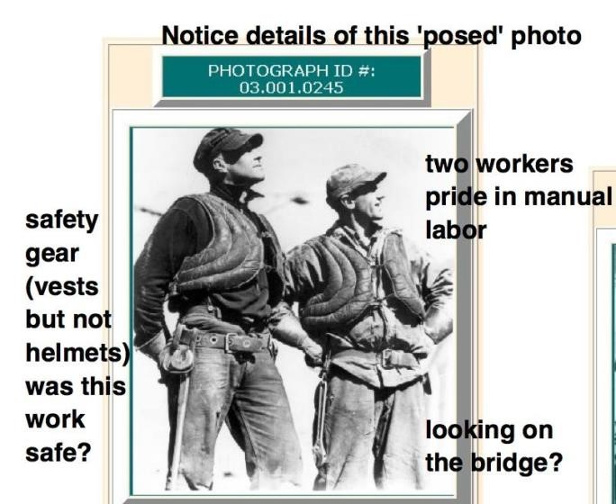
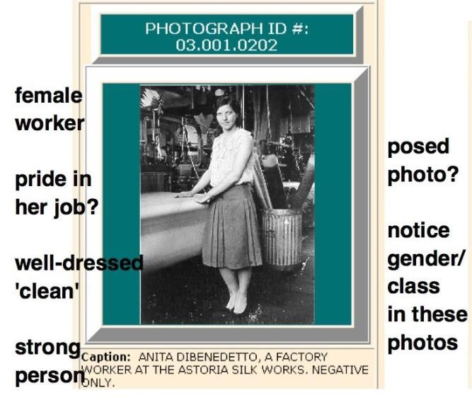
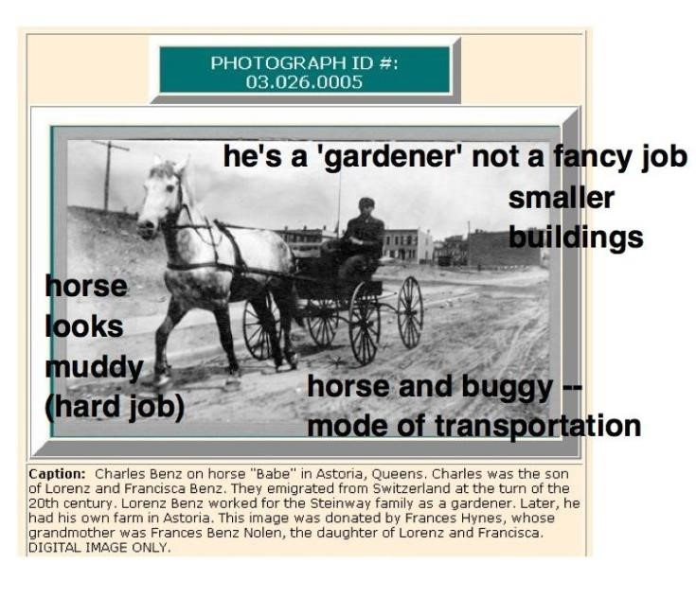

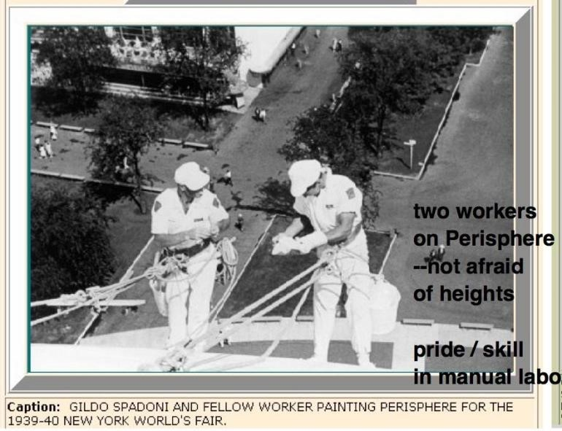

2 PLACES FROM QUEENS HISTORY:

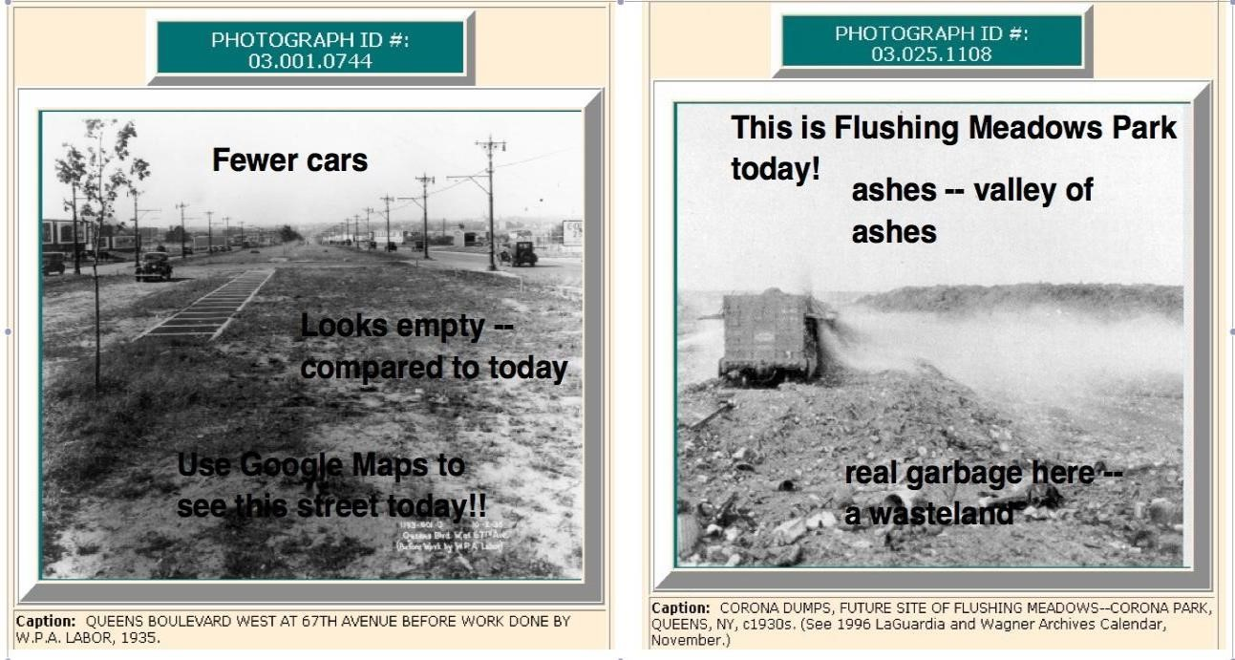

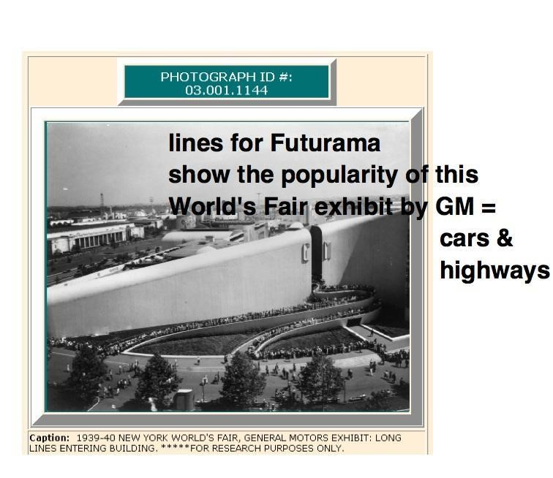

----
----

---------------------------------------
** NEXT TIME – TUE. 10/11
---------------------------------------

- A PRINTED PRELIMINARY DRAFT OF ESSAY #1 IS DUE TUESDAY, 10/11 (2:15 pm).

Please bring 2+ PRINTED PAGES TO CLASS THEN

2) Finish the Analyzing a Sample Essay #1 -- DUE FRI. 10/7 (11:59 pm)

3) Reading: Andrew Curry's "Why We Work" -- Posted online at eng101.lagcconline.com -> Bottom of Course Documents for Session #6

