----------------------------------------------
ENG 101 Class Notes
Session 14
Thu. 11/3
----------------------------------------------
**TO DOs**

Updated Course Syllabus (5 min)

Videos on The New York World’s Fair 1939-40 (15 min.)

***Explore some primary and secondary materials on 'Futurama' and The World's Fair 1939-40

The Futurama Souvenir Brochure (45 min.)

***

IMPORTANT COURSE READING – For Essay #3 (and Final Exam / Essay #4)!!

***David Gelernter, 1939: The Lost World of the Fair, Part 1

Reading | Group Work | Discussion (2nd hour)

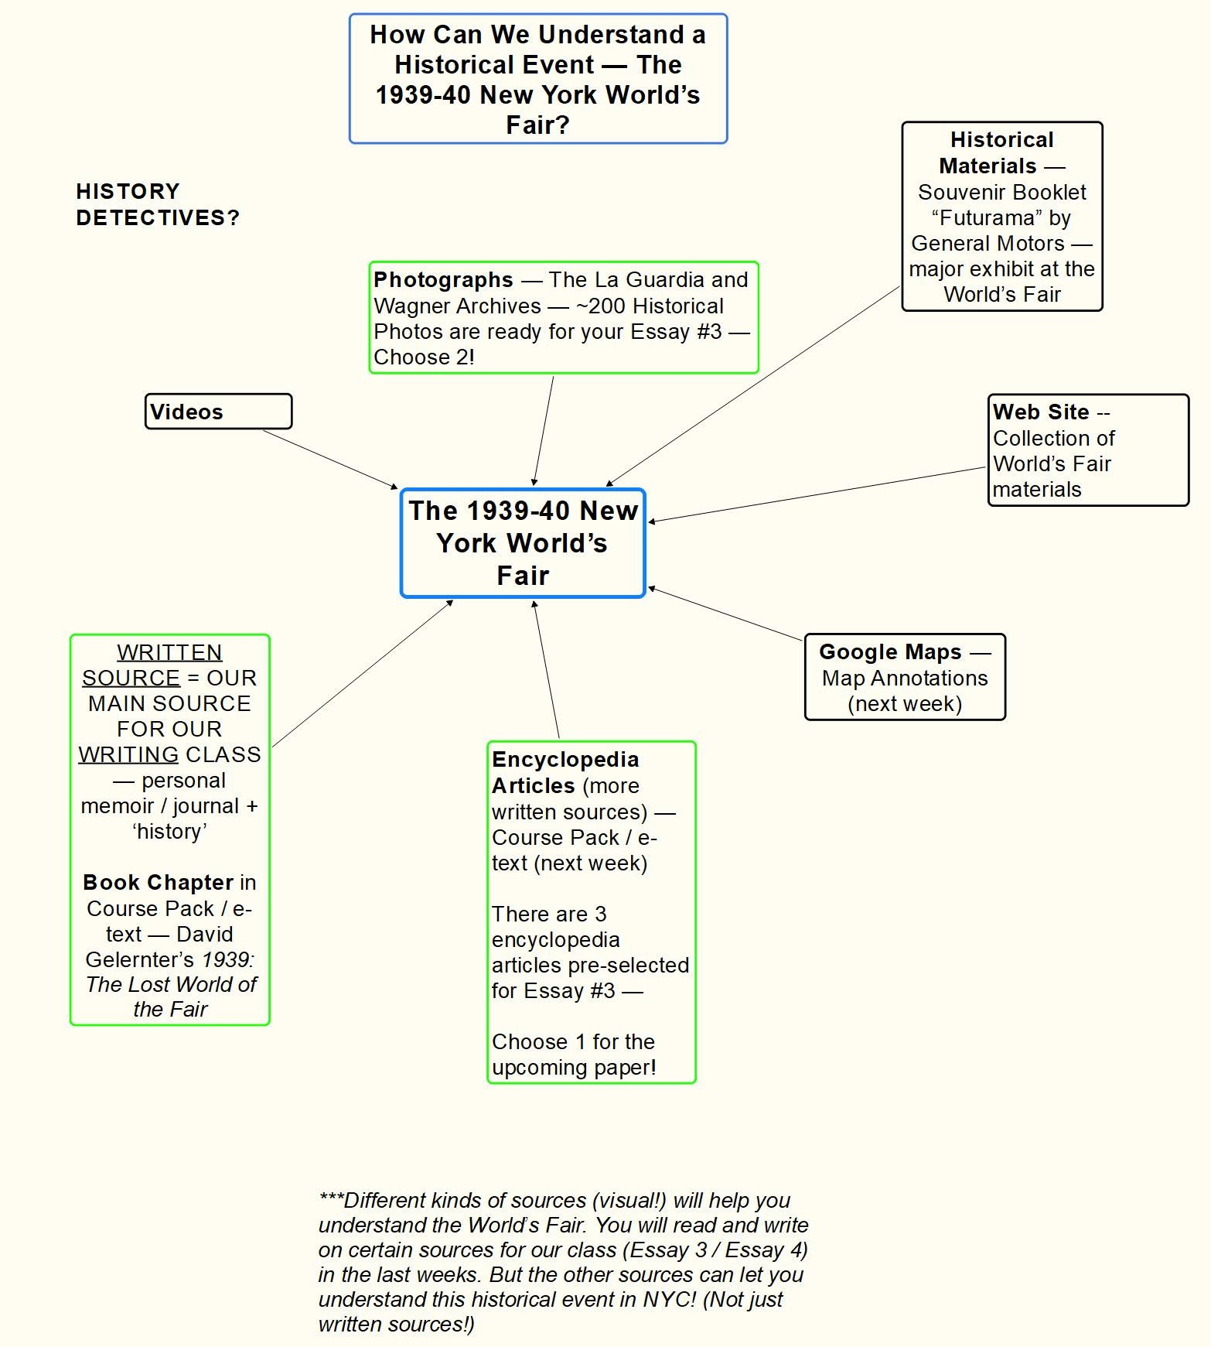

***A Few 'Big Questions' to Think About:

- What's the best way to describe a place? ​Writing?
Personal writing (diary?)? ​Photos? Movies? ​A ​diorama
(small-scale model, used in architecture and Futurama at the World's Fair)? A​ computer simulation (by an academic​ research / Google Earth / a video game)? What are the advantages / limits of each?

- Did the World's Fair of 1939-40 actually get a lot of things right​ when it came to American life in the 1960s (the "Future"​ from the​ p.o.v. of 1939)? (For example, cars / cities / suburbs​ / numerous​ technological inventions.)​

- In a pessimistic time (the Great Depression)--and just before WWII, how did the World's Fair managed to be incredibly optimistic ​about the Future?

- ​How do we imagine the Future today? ​What will it be like? Are we as optimistic as in the past in 1939?

------------------------------------------------------------
Futurama Booklet (pp. 92-101) in Course Pack
------------------------------------------------------------
1) ​Who is the ‘author’ of this souvenir booklet? ​Does that make​ its content more or less reliable?​ Why?

*CEO of GM Alfred P. Sloane, Jr.
Advertising! GM sells cars.

HIGHWAYS!!!

***GENERAL MOTORS
**Less reliable -- advertising! *Advertising their products CARS!!!

HIGHWAYS!!!

More reliable -- CEO of GM??
Well-spoken -- persuasive -- tie in building transportation with economic prosperity

Advertising!!! Journalism?
Could be telling the truth -- but he'd lose people's trust

Trust in brand!!!

2) Which type of source (booklet or video or written sources -- later) is more appealing? Which is probably more accurate? Why?
*Answers

IDEAL! -- candid video --

Today, we have video for everything....

PHOTOS!

Written sources -- COMBINE SOURCES to get a better understanding of the past!

DIGITAL ARCHIVE -- La Guardia & Wagner Archives

NYPL Biblion -- Another digital record of World’s Fair materials

Websites

3) What is the vision of the future for cars and highways in the brochure and video clips from Futurama?​ Do the videos and photos in the brochure look like real highways today? ​Did the vision of the future in 1939 ‘come true

The cars, highways and growth of the suburbs predicted in Futurama came true.

CAR OWNERSHIP skyrocketed after highways were built in 1950s+.

**CARS AND HIGHWAYS
***
utopia -- perfect place

Travel faster with less cost -- economic!

Some of it did come true -- more highways -- on ramps / off ramps

Multilane highways (new idea!)

Lots of cars!!! But they do slow down to get on / get off the highway....

Side effects?

Traffic jams / accidents!!
Pollution!!
Global warming...

Highways look more futuristic -- more lanes!!
Came pretty close to idea of a highway....
Looks exactly like Futurama -- same architects
Today -- even extreme changes
Telephones TV -- did advance -- Blu-Ray -- wifi -- Robot dogs??? vs Siri

The buildings in the Futurama exhibit resemble some of today's buildings.

Gelernter Part 1 – Reading on the World’s Fair (25 min.)

Reading Questions (30 min. #1, #2 & #3)

Reporting Out (Submit Your Answers / Class Discussion)

--------------------------------------------------------------------------------
“Technology: Good” by David Gelernter (pp. 122-129 in the Course Pack)
--------------------------------------------------------------------------------
1) In the opening short diary section (p. 122), Hattie Glassman says, “I have always wanted to feel what that time was like [...] that if, somehow, I could feel an era before I was born, the scales would fall from my eyes & I would then be able to feel my own life” (Gelernter 122).
Explain what she means by this sentence in a short paraphrase. Also, what is the advantage of using a diary (as personal writing) to give the reader a sense of what it was really like to visit the fair?
*She makes it seem like looking at past could help her present. Look to the past to understand the present.

She can better understand her life by understanding the period before her.

History repeats itself.
**She will understand her present better by understanding the past. **Looking at past technology, we’ll understand today’s technology (POSITIVEs and negatives).
*With a better understanding of the past, you can understand what you’re going through today (PAST -> PRESENT) **Diaries contain memories, and own personal newspaper
(record) -- thoughts and feelings / MORE PERSONAL

PERSONAL NARRATIVES vs. OBJECTIVE SOURCES
Hattie Glassman
*Having an opportunity to experience a different era...
**Era of her mother -- she would understand herself. *Maybe she felt that she experienced life before what life was like, she would be able to understand her world....

history --> to understand the present better understanding of herself....

Looking toward the past would her open up and let analyze her life....

*If she could see the technology of a different time, she would understand her time (1930s)
**Looking at technology with a historical perspective lets us understand it better.

2) As a group, decide on what Gelernter’s main argument or thesis is about technology at the World’s Fair. Can you point to a sentence and a page number that states his position on the difference between the rate of technological change in the 1930s and today?
*Answers

TECHNOLOGY THEN TECHNOLOGY NOW
1900 – 1939 > TODAY

*Gelernter is for ‘everyday’ technology -- refrigerator replacing the ice box. He prefers basic practical inventions.

He writes, "Older people on the 1939 fairgrounds had lived through the most spectacular technology-driven world transformation in history" (Gelernter 128).

Technology Then Technology Now
1900 - 1939 1990s -- Today

MORE IMPORTANT! LESS IMPORTANT

3) List two examples of the most important practical technological improvements that people at the fair in 1939 would have experienced in their lifetimes. You can use his list in the section on the bottom of p. 128-129 of the Course Pack for some ideas.
*Answers

*Cars!
**Airplanes! ***X-rays **Engines!
*Movies!
**Television!

(Today we can get TV / movies on our phones, but what if this technology didn’t exist?)

**Lines in the middle of road -- prevents accidents
**Transportations -- cars
**Movies
**Videophone -- prototyped
**Elevators
**Refrigerator
**Vacuum cleaner
**Robots (demo. at the Fair)
***Gelernter points out that women in particular benefited from this technology.

4) Challenge Question: Finally, is Gelernter an ‘optimist’ or a ‘pessimist’ about technology and why? (Why doesn’t he think that more recent innovations like the computer -- smart phones -- are as important as elevators, washing machines and the other inventions onpp. 128-129?)
** More of an optimist
**Optimist because he looked at how things improved in the 1930s....
**Optimist because he understands how pivotal these technologies were....
FOR REGULAR PEOPLE

**Yes because he really value core technologies -- 1900-1939.... -

----------------------------------------
NEXT TIME -- TUE. 11/8
----------------------------------------
1) We’ll finish our Gelertner Part 1 Reading.

2) Spend some time browsing the World’s Fair links – use the VISUAL MATERIALS to understand this historical event.

3) We’ll finish the Gelernter Challenge Question #4 next time.

4) Midterm Essay #2 will be graded as part of your Grade Book
posted by next Tues.

Good work on the Midterms!

(You can still makeup the Midterm. Send an e-mail to eng101.lagcc@gmail.com to schedule a time during a class over the next 2 weeks. You will take the Midterm for 2 hours.)

